Invitation for Bid
HIF-WAIHOOLANA-25
WAIHOOLANA UPPER FENCE INSTALLATION, Hawaii Island
OVERVIEW
The State of Hawaii’s Division of Forestry and Wildlife (DOFAW) is seeking bids for constructing an ungulate-proof fence within the Kohala Watershed Partnership (KWP) management area at Waihoolana, as well as associated tasks such as clearing the fence corridor. The successful bidder will enter a contract with the State of Hawaii, from which the fence project will be executed with a State of Hawaii Purchase Order (PO).
The bidder will also provide a performance bond and payment bond to ensure completion of all portions of the project to the specifications herein and payment of any materials or labor debts.
There will be a pre-bid conference for the Waihoolana upper fence project so that there is ample opportunity for contractors to view the project area and ask questions. Below are details for the pre-bid conference. Attendance to the pre-bid conference is mandatory to submit a bid.

Mandatory Pre-Bid Conference: Meeting will take place on December 11, 2025 at 8:00 am.

Prospective bidders will meet at the front gate of the Kehena Ditch Rd (20°09'42.3"N 155°48'59.5"W)
which is located on the upland side of Hwy 250 between mile markers 15 and 16. The following is a Google Maps link to the meeting location: https://maps.app.goo.gl/WgXXjcdFLxJVLLYH7

DOFAW/KWP will provide transportation from the parking area about one mile in on the Kehena Ditch Rd to the site. Bidders will access the site by vehicle, UTV, and foot to inspect project infrastructure and the proposed fence route during the pre-bid conference. The sites are in mountainous terrain, where the weather is typically cold and wet. Maps will also be provided.

As a courtesy, please contact KWP’s Mahina Patterson (pohaip@hawaii.edu or (808) 289-2903) at least one week prior to the meeting to confirm attendance. In addition to the mandatory pre-bid conference, bidders are strongly advised to inspect the general fencing area prior to submitting a proposal, either by examining habitat by doing a “fly-over” of the fence installation site at the bidder’s expense or reviewing Geographic Information System (GIS) shapefiles, as well as Google Earth files, of the fence route. These files are available for review by contacting the Contract Administrator. Topographic and logistic conditions present difficulties that are not typical for fence installation projects. Failure to inspect the work area/installation site will in no way relieve the successful bidder from completion of the work in accordance with the specifications, terms, and conditions herein to the satisfaction of the Contracting Officer’s Representative.

Schedule of Key Dates: Table 1 below represents DOFAW’s best estimate of the schedule. If a component of this schedule is delayed, the rest of the schedule will be adjusted accordingly.

Waihoolana Upper Fence Pre-Bid Conference | December 11, 2025
Deadline to Submit Written Inquiries | December 19, 2025
DOFAW’s Response to Written Questions | December 30, 2025
Deadline to Submit Bid* | January 9, 2026
Table 1: Schedule of Key Dates.

SCOPE OF WORK
The objective is to protect and preserve approximately 400 acres at Waihoolana of irreplaceable watershed, unique native ecosystem, as well as the rare and endangered species it supports. The project areas are owned by Ponoholo Ranch, Makani Ua Ranch, Kahua Ranch, and the State of Hawaii. The access road to this property also goes through Parker Ranch lands. The State has access agreements for the Contractor to access these properties.
Minimum Qualifications:
To be considered for this contract award, an Offeror must meet the following minimum qualification:
Must be familiar with installation of ungulate-proof fencing in remote areas with rough terrain and have had related project experience in Hawaii. Offeror shall provide in their proposal a description of and references from at least two feral-ungulate-proof (e.g., pig, goat, sheep, or deer) fence installation projects in remote areas with no roads (requiring helicopter transport of materials and/or crews) and rough, undisturbed terrain in the State of Hawaii of at least 9,500 feet.
A contractor’s license is not required to bid on this job.
Waihoolana Upper Fence Project Details:
At Waihoolana, approximately 9,500 feet of fence will be constructed (see Figure 1 below).
Minor changes in the fence alignment may be made due to terrain or avoidance of sensitive features, such as the identification of endangered plants and/or archaeological features. The State reserves the right to purchase larger or smaller quantities at the per linear foot price quoted on the OFFER FORM page.

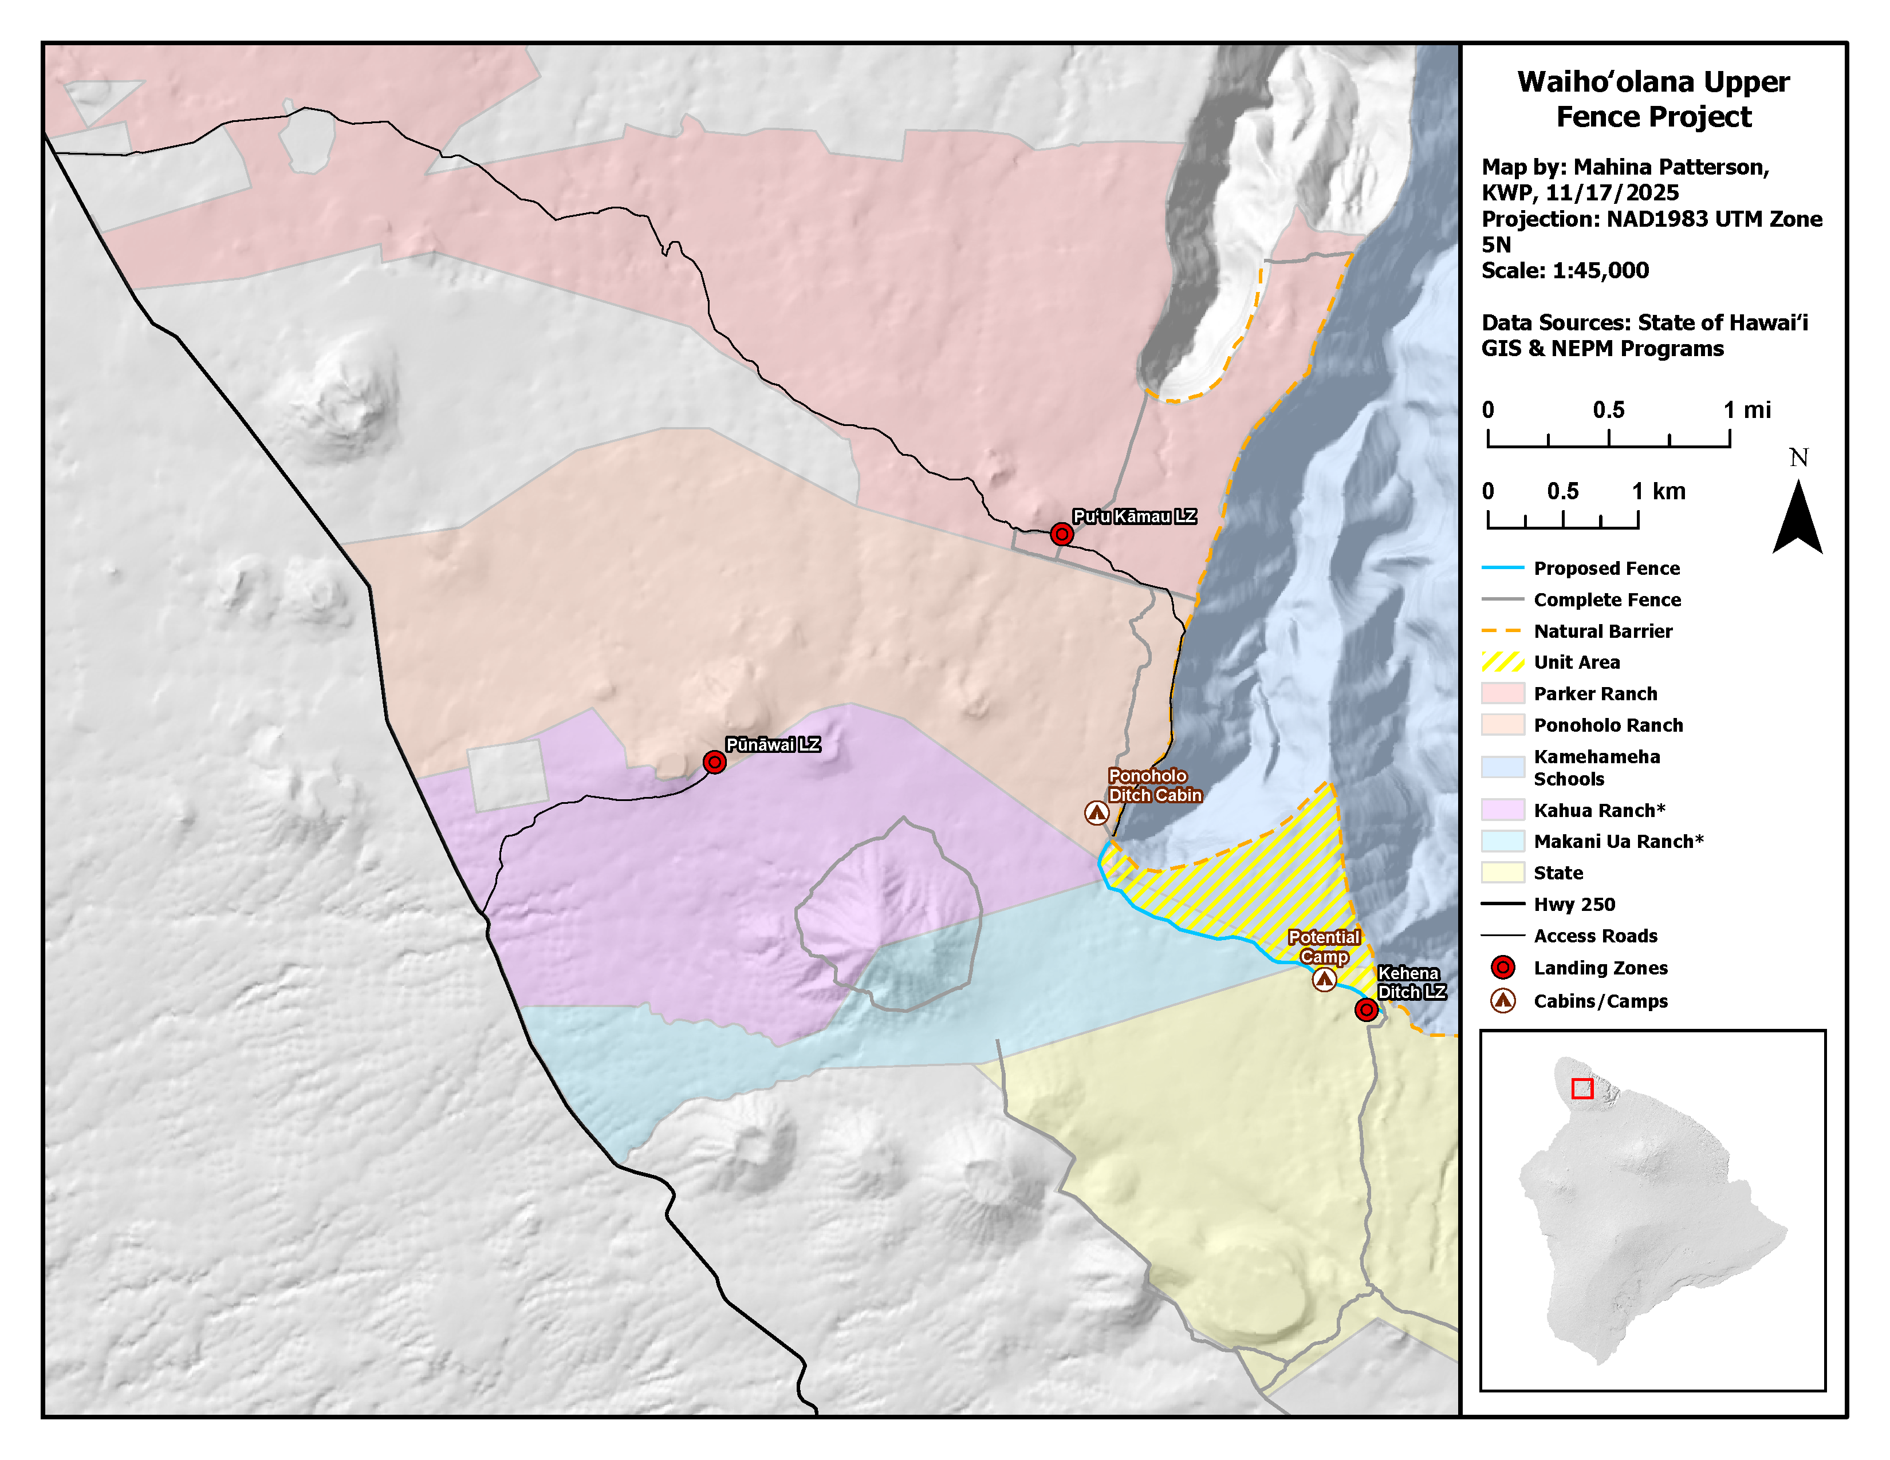 Figure 1: Waihoolana Upper Fence Project and Infrastructure. *The boundary between Kahua and Makani Ua ranches from Puu Pili to Hwy 250 needs to be updated but does not impact this project.

Access:
The Waihoolana upper fence project can be accessed by vehicle and helicopter. The western side of the fence project can be accessed using a 4x4 vehicle from the Kehena Ditch Rd to Kaneaa on Parker Ranch and ATV/UTV through Kaneaa and Pupukanioe on Ponoholo Ranch. The rest of the fence project is more efficiently accessed by helicopter. The Contractor will notify DOFAW, KWP, and the appropriate landowners of the dates of access in advance (at least two weeks prior) and coordinate directly with the appropriate landowners on any further logistics such as key pick up and vehicle/equipment staging locations.
The Contractor shall be responsible for transporting all required fence material, tools, work crew, and equipment to the installation sites. Equipment may be stored on-site at the Contractor’s own risk. DOFAW will not provide any helicopter transport for the Contractor’s crew or material. The Contractor shall coordinate its work schedules, timing, and other relevant communications directly with the Helicopter Contractor; however, the Contract Administrator and KWP shall be notified at least two weeks in advance of proposed work and flight schedules and included in pertinent communications affecting the project. The Contractor must complete a full walk through with a DOFAW/KWP representative prior to commencing. The Contractor must obtain all necessary landing permits prior to commencing work. Landing permits are applied for through the DOFAW Hilo office, 19 East Kawili Street, Hilo, HI. All permits must include a schedule of work and list the Contractor’s staff working on the project at the time. The Contractor will work with DOFAW/KWP to identify appropriate helicopter landing zones (LZ). There are several helicopter landing zones, a few of which are shown on Figure 1. The Punawai LZ accessed through Kahua Ranch will be the primary LZ. Helicopter operations on private land need to also be coordinated directly with the appropriate landowners.
The Contractor is advised that hunting occurs within the project area. When working in the project area during hunting days, it is advised that all precautions necessary are taken to avoid conflicts with hunters and that work crews advertise their presence in the area including by wearing blaze orange colors. The Contractor is NOT permitted to hunt.
Terrain:
Within the project area of Waihoolana, the vegetation is characterized as an Ohia (Metrosideros polymorpha) Montane Wet forest with native understory tree species, uluhe ferns, and scattered assemblage of native and non-native ground species that include sedges, grasses, herbs, shrubs, and ferns. The ground can be uneven, rough, and undulating. The ground can be loose or solid rock, soil, or mud. (See Figures 2, 3, and 4 below.)
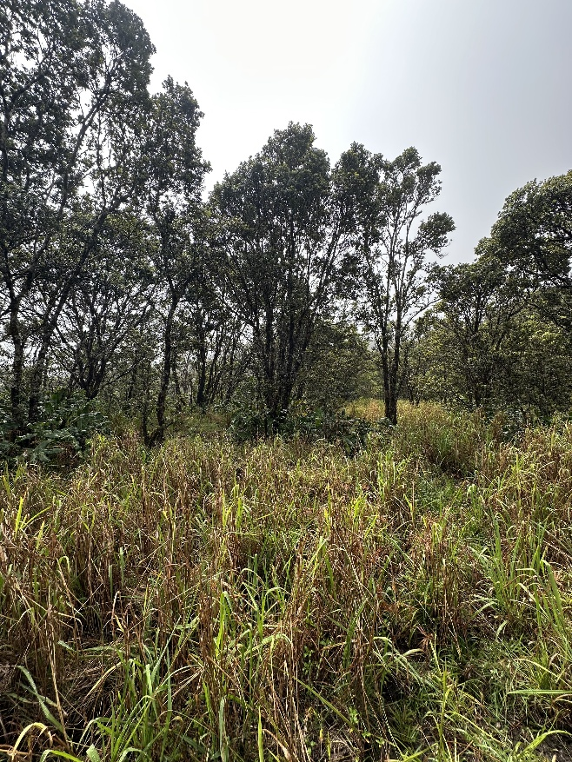 | 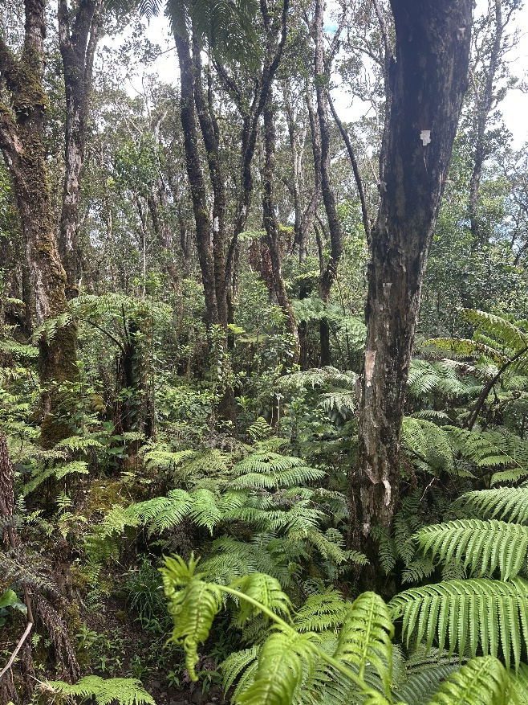
Figures 2 and 3: Photos of the project area terrain and vegetation.
Site Preparation:
The fence corridor will be delineated and flagged by DOFAW/KWP. The Contractor shall be responsible for picking up and delivering materials, brushing a fence corridor, fence construction, and post-construction clean up. It is recognized that for installation purposes the Contractor may choose to shift the flagged alignment slightly. The fence alignment may need adjusting prior to and/or during corridor clearing, and only after consultation with DOFAW/KWP. Upon approval, the Contractor may re-align the fence to straighten alignments, to adjust corners, to avoid certain trees and shrubs, to avoid any rare plants or potential archaeological structures. The Contractor shall be responsible for brushing (removing) some vegetation on either side of the final or corrected fence alignment (no more than ten feet total) as the fence shall be constructed at the midpoint. This may include some shrubs, ferns, and both non-native and native vegetation. Brushing of plants along the fence corridor should only remove those plants that may hinder fence construction or future fence inspections, such as potential overhangs, unless it has been determined that the tree is an endangered species (State will flag any endangered species with pink flagging). Note that it is not necessary to remove all vegetation. In addition, large healthy native trees shall be avoided as much as possible. Any native trees (mainly ohia) that are taller than 5” (from ground level) and/or 6” in diameter, may not be cleared. Any native trees, especially ohia, that are cut or limbed must be sprayed with Spectracide to close wounds. Hand clearing is required.
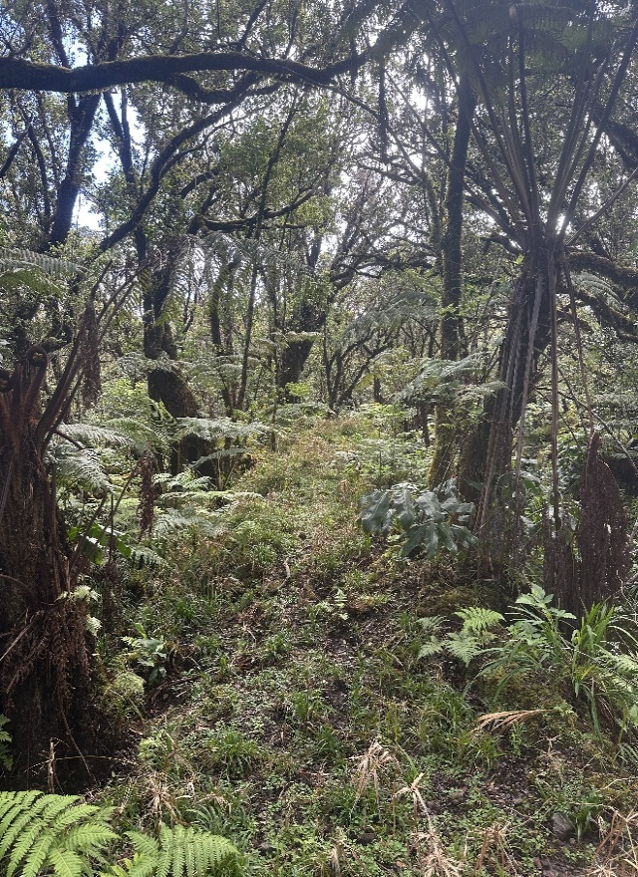
Figure 4: Photo of the project area terrain and vegetation.
There are no known archaeological sites within the fencing corridor, but if found they will be flagged and must be avoided. If the Contractor finds bones or cultural artifacts at any time during site preparation or installation, work must immediately cease and DOFAW/KWP notified promptly. The entire fenceline is within endangered species habitat and thus extreme caution must be used during clearing and installation of all phases of the fenceline. The State has conducted biological surveys and has flagged all known rare species locations. The Contractor will be responsible for not damaging those resources. All human litter and waste must be removed from the site at all stages of fenceline installation.
Camping:

Use of the Ponoholo Ditch Cabin, as well as camping at the Kehena Ditch LZ are permissible, pending approval from Ponoholo Ranch and the Hawaii Island District DOFAW office, respectively. Additionally, camping along the fenceline may be permitted, subject to approval by Makani Ua Ranch and DOFAW, respectively. The Contractor must follow all applicable guidelines, as outlined by the landowner.
Weather:
Weather conditions at the fence site are at times extreme and may change rapidly. Therefore, the work activity is weather contingent, and the Contractor must have a flexible schedule and be able to respond when weather conditions allow access. Similarly, hauling equipment/materials on access roads/trails is not permitted during or immediately after rain events, as to prevent unnecessary wear on existing infrastructure.

Equipment:
The Contractor shall be responsible for the provision of the necessary installation equipment, supplies, tools, and all labor required to install fencing as specified herein. The Contractor shall be responsible for providing their own transportation of all materials, crews, equipment, and supplies to the site.
The Contractor is advised that DOFAW/KWP shall not supply communications equipment. The Contractor is advised that DOFAW/KWP shall not supply personal protective equipment (PPE) for use when working in or around helicopters.
The Contractor may not use the DOFAW/KWP baseyard as an office or staging area; for storage of tools, supplies, equipment, or other materials; or for overnight vehicle parking.
Native and Alien Plants and Animals:
The purpose of this project is to fence valuable watershed and important habitat with high conservation value. Plants or animals may not be removed from the fencing sites. The Contractor will implement precautions to prevent the introduction of alien plants, animals, and insects. Boots, equipment, and materials will be cleaned and inspected by the Contractor for seeds, eggs, larvae, etc. All equipment and personal belongings must be treated to prevent the transmission of Rapid Ohia Death (ROD), Little Fire Ants, and Coqui frogs. The Contractor will also take precautions to prevent spreading alien plants already found at the fencing sites. For Contractors arriving from other islands, contractors must perform these tasks prior to transporting your equipment and personal gear to Hawaii. The Contractor will not store materials prior to material drops in areas known to contain ROD, Little Fire Ants, Coqui, etc. The Contract Administrator and KWP reserve the right to inspect all gear prior to deployment to ensure cleanliness. The Contractor will remove all food, refuse (including human feces), tools, gear, and installation scrap upon completion of work at each fencing site. Extra fence material may be left at the site (during project activity), panels discreetly attached upright to existing fence, T-posts bundled on the inside of fence area, skirting on the inside of fenced area, and all excess material stored away from fissures or ridges.
Communication:
DOFAW and KWP recognize that the Contractor may not work on the job continuously from start to finish. At the same time, DOFAW and KWP have management responsibilities that must be coordinated around the fence installation schedule. Thus, the Contractor shall notify DOFAW and KWP at least two weeks in advance whenever work at the job site is planned to begin and shall notify DOFAW and KWP within one (1) week of leaving the job site if the Contractor plans to be away for more than one (1) week.
Project Completion:
The Contractor will remove all scrap (e.g., wire mesh, smooth wire, damaged posts, and discarded spades), tools, and trash. Surplus materials such as fence posts will be arranged neatly at a material depot identified by KWP.

Materials:
DOFAW will supply the following materials of the following specifications to complete fence installation, including:
- Woven wire mesh: 1348, 48” high-tensile steel X knot woven hog wire fabric with Bezinal or Galfan coating
- Panels: High Five corral panels 16’ x 5’ hot dipped galvanized, 4” spacing
- Apron/Skirt: 832, 32” high-tensile steel X knot woven hog wire fabric with Bezinal or Galfan coating
- T-posts: 7’ T-133 galvanized steel posts with anchor plate
- Corner posts: 8’ (240 cm) galvanized Jio Max Y posts
- Anchors: 24” T-133 galvanized steel posts with anchor plate
- Stall mats: 6’ x 4’ stall mats, 3/4” thick
- Smooth wire: 9-gauge straight wire with Bezinal coating
- Fasteners: Clips, Bezinal coated, minimum 11 gauge
- Hog rings: 9 gauge with Bezinal or Galfan coating

The Contractor will provide the following:
- Pedestrian gates: 3 will need to be fabricated.

All fence materials purchased by the State will remain the property of the State. Following completion of the fence installation project, the Contractor will pick up any excess fence materials not required for the project and return it to an identified material depot. The Contractor is responsible for providing other materials including but not limited to materials for pedestrian gates.
This fence material will be available for pick-up at the KWP baseyard in Waimea (66-1380 Mamalahoa Hwy). KWP staff will coordinate with the Contractor on fence material pick-up. Contact information will be provided to the Contractor.
The Contractor is responsible for transporting all required fence materials to the fenceline from the baseyard, labor to construct the fence, and any necessary clearing of vegetation along the fence corridors.
FENCE SPECIFICATIONS
- General
This fence is intended to exclude feral pigs and cattle. The following specifications are necessary to ensure the fence prevents ungulates from entering the area enclosed by the fence and to minimize long-term maintenance. The fence will be carefully inspected and approved by DOFAW staff or their KWP representatives prior to all payments to the Contractor to ensure that the following specifications are met.
The wire mesh will be a minimum of 48 inches high, measured perpendicular from the ground surface and attached to the outside of the Max Y posts and T-posts using fence clips or 9-gauge smooth wire. ALL high and low points need to have a post. Fence corners will be constructed using 8’ Max Y posts and appropriate bracing. Anchors and/or wire mesh skirting will be used in areas of uneven or rocky ground or deep mud. To ensure that the fence excludes ungulates, the bottom of the woven wire will ideally be flush to the ground. If the Contractor has an alternate means of securing skirting, then consultation should be provided to the Contract Administrator and KWP.

- Posts (Corner and T-Posts)
All posts will be installed within 5 degrees (or two [2”] inches) of plumb. T-posts will be placed within three (3”) inches of a centerline drawn between the corner posts. Standing trees or logs may not be used as fence posts.
Corner Posts: Max Y posts will be used for corner posts. Corner posts will be driven to a minimum depth of thirty-six (36”) inches.
Max Y posts also will be installed at abrupt changes in slope along the fenceline to allow the wire mesh fabric to be cut and oriented as smaller panels that better conform to the topography. In areas where the fence makes long, straight runs on level ground, Max Y posts will be installed every 100 feet, as in-line braces at appropriate locations to reinforce the T-posts.
T-Posts: T-posts will be spaced no more than 8 feet apart and closer when terrain dictates. T-posts will be installed at ALL high and low points along the fenceline to prevent the wire from “bellying.” T-posts shall be driven to a minimum depth of 30 inches. The T-posts shall be driven by use of a tubular post driver in a manner that will prevent damage to the posts. Where posts are to be installed in solid rock, the spade anchors may be removed so that posts fit tightly in drilled holes. All cuts will be sprayed with a cold galvanizing paint. T-posts shall be driven perpendicular to the slope when the terrain is 45 or more degrees so that the height of the fence is not compromised over steep terrain sections. All other posts will be installed within 5 degrees (or two [2”] inches) of plumb. T-posts at low points should be driven deep enough to prevent them from being pulled up when tension is applied to the wire mesh. If a post does pull out, hanging rocks or other weights from the wire is NOT an acceptable means of re-anchoring the post. Posts which are bent, split, mushroomed, cracked, twisted or have cracked, chipped, or scratched coatings will not be used.

- Braces
Any point where the fence changes direction is considered a corner, and the appropriate brace structure will be installed to support the corner post. Unless prevented by terrain, all braces will be constructed using 8’ Max Y posts driven at least three (3’) feet into the ground. Brace type will depend on which direction the fence turns relative to the inside or outside of the fenced unit.
When the fence turns inward (toward the inside of the fenced area) the “push corner” method will be used. Use a single T-post to brace the Max Y post. The brace T-post should be oriented at the angle that counters the direction of pressure from the fence on the corner post. The brace T-post should be driven into the ground at an angle, so the bottom is at least three (3’) feet away from the base of the Max Y post and the top of the T-post meets the Max Y post about four (4’) feet above the ground. Smooth wire should be tied halfway up both posts to connect them. The smooth wire should be tied in a fashion that pulls the T-post firmly against the Max Y corner post (see Figure 5).
Where the fence turns away from the inside of the unit the Max Y post can be braced using the “tie-back” method, using smooth wire tied to the top hole on the Max Y post to an anchor T-post driven into the ground at least four (4’) feet away inside the unit. The brace T-post should be driven into the ground at a 45-degree angle (see Figure 6).

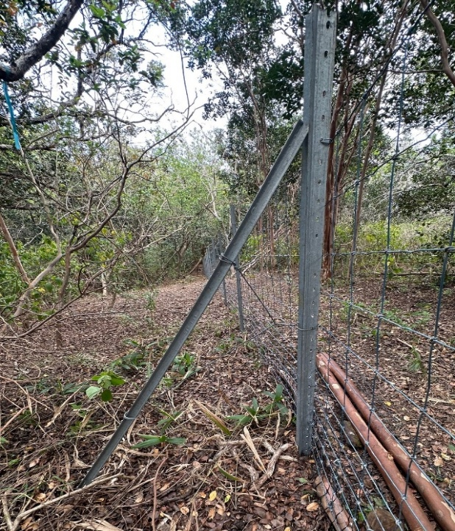 | 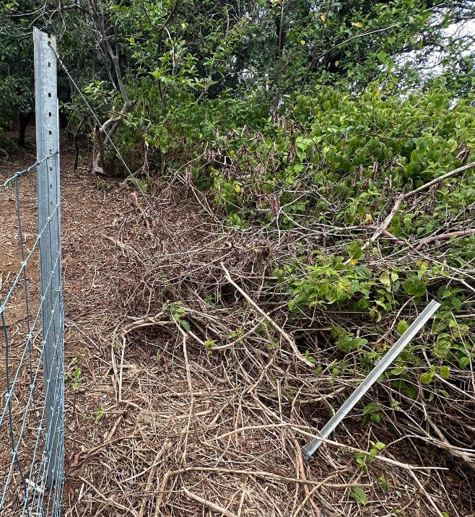
Figure 5: Example of a “Push Corner.” | Figure 6: Example of a “Tie-Back.”

- Woven Wire Mesh
Woven wire will be deployed with minimal damage to galvanized coating. As practical, crews will avoid stepping on wire and avoid climbing on or over erected mesh. The mesh will be fastened to all posts at the top and bottom at a minimum of six (6) evenly spaced points. Wire mesh will be fastened to the outside of T-posts and outside corner posts; the side where ungulate pressure will ultimately occur. Mesh may not be secured to tree trunks. All wire is to be stretched and fastened with approved fence clips. Tension shall be applied to the wire with a ratcheted belay or other suitable equipment such as a motorized winch or come-along to the manufacturer recommendations, taking into consideration field conditions.
Adaptations to terrain: Woven wire will not be deformed to adapt to variation in contour. “Bellying” is unacceptable. Where a radical change in slope occurs, wire will be cut and tied off and a new section started at an angle that matches the terrain. New sections of wire mesh will be cut to match the angle of corner posts on either end of the section in question. Posts and braces will be used at these locations. High Five Panels may be used for short segments with extreme slopes or terrain.

- Apron (or Skirting)
The bottom strand of mesh wire will be fastened to each T-post so that it is flush with the ground surface or no more than one (1”) inch above the ground at any point along the fence and fastened to the ground with appropriate anchors. This criterion will be scrutinized during inspections prior to payment. If anchors cannot close a gap greater than one (1”) inch between the bottom strand and the ground an apron must be installed.
Apron shall be 32” high tensile woven wire. The apron should overlap along the bottom of the fence by 2 rows of squares or maximum 1 foot and attached so that the overlapping squares are positioned vertically over the panel and the remaining hog wire is stretched horizontally over the ground on the outside of the fence. Apron shall be attached to the wire mesh using hog rings. One hog ring shall be used per square of mesh and attached to the panel in an alternating pattern between the bottom of the wire and the bottom of the fence. Apron should extend 1 ½ feet beyond the vertical plane of the fence. The edge of skirting will be secured with appropriate anchors. A tie wire shall be attached to the anchor through the hole provided in the pin and then tied to the apron. Anchors shall be spaced no more than 15 feet apart. To the greatest extent possible, anchors must be buried in the ground. Terrain will dictate the number of anchors required per length of skirt. For this IFB, the ground surface is the soil surface and not the vegetation mat. The vegetation mat and loose soil will be manually cleared as needed to ensure the above specifications are met. In cases of rugged and severe terrain, skirting will be required to maintain the cumulative 48” height of fence and tight relation to the ground. Where obstacles such as rocks or large roots appear, either these items must be removed (if approved by KWP staff) or the apron must be installed to fit tightly around these surface irregularities.

- Hog Rings
Hog rings shall be used to secure the apron to the bottom of the panel fence as described in the apron section above.

- Clips
Clips shall be twisted tight enough to be secure. Over-tightening to the extent of damaging the smooth wire or causing the clips to break is not acceptable. Both ends of the fence clips shall be properly tightened so that clips are not loose and there is no play between the clip and the T-post. Wire mesh shall be attached with clips to each post by the top and bottom wire and at least four (4) interior wires. Clips shall be Bezinal coated.

- Anchors
Anchors are to ensure that the gap between the bottom strand of the wire mesh and the ground is no more than one (1”) inch and may be 7’ T-posts (T-133) or 24” T-posts (T-133).
24” T-post anchors will be driven at a 30 to 45-degree angle such that the tops are no more than two (2”) inches off the centerline and that no more than three (3”) inches is protruding from the ground surface. Posts will be attached to at least two (2) of the bottom strands of woven wire with 9-gauge wire. Posts will be driven to pull the tie tight.

7’ T-posts can be used to close the gap between the bottom strand of the wire mesh and the ground as well. T-posts used for anchoring should be driven as deep as necessary to keep the fence anchored to the ground. The posts will be installed within 5 degrees (or two [2”] inches) of plumb unless the ground slope is 45 or more degrees, in which case the T-post anchor will be driven perpendicular to the slope. T-post anchors should be secured to the wire mesh with at least two (2) clips.

- Pedestrian Gates
Self-closing step through pedestrian gates will need to be fabricated (and materials provided by the Contractor). Gates will be a minimum of 75” working height with additional 6” stub-outs on bottom. Total length of vertical pipes will be 81” minimum, 96” maximum – single piece pipe (not welded). Total width is 36” with a swinging gate 28” W by 36” H. There should be a 32” high fixed step over. 2” x 4” square steel dipped galvanized paneling will be used for fixed gate mesh portions. Perimeter pipe will be 2 3/8” OD Schedule 40 galvanized steel pipe. Gate will be designed as a self-closing gate, using heavy duty weather resistant Tru-close hinges or equivalent. All hardware will be galvanized including any screws, bolts, or mounting hardware. Gate will swing in only one direction and have a gate stop. The step over must allow human traffic and yet prevent ungulates from crossing (see Figure 7).

Braces: Pedestrian gates should be braced on either side by Max Y posts driven at least three (3’) feet into the ground. The wire mesh should be tied to the Max Y posts, and the Max Y posts should be tied to the pedestrian gates with smooth wire in three (3) equally spaced ties on each side, six (6) total.
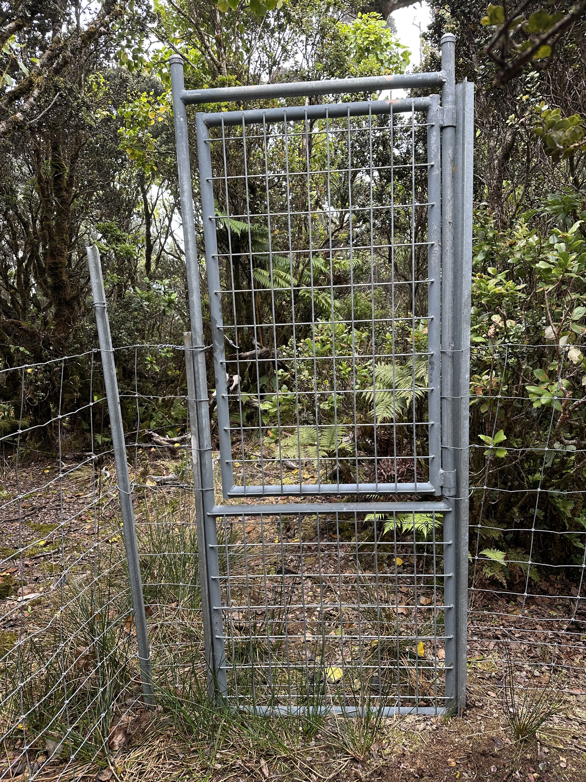
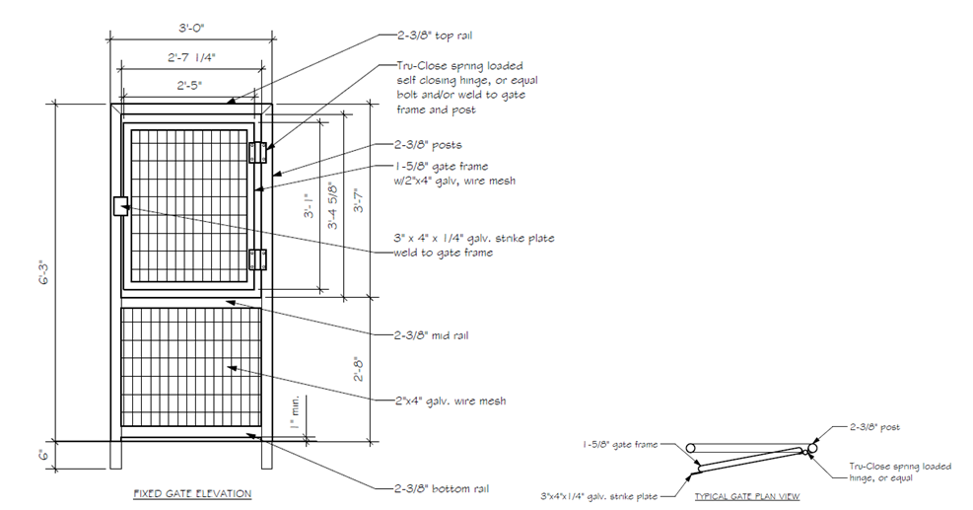
Figure 7: Pedestrian gate diagram and example. Note: The example is not completely built to the required specifications but is meant to serve as a helpful reference photo.

- Stream Crossings
Where the fenceline crosses streams, methods should be used to keep the fence integrity intact, while letting water flow through when the streams are running.
Anchoring: On both sides of the stream, install 8’ Max Y posts driven at least three (3’) feet into the ground on the stream banks. Place these posts well above and outside the high-water mark.
Fence options at stream crossings:
1) Continue the wire mesh stretch over the stream. Hang stall mats below.
2) Terminate wire mesh at each anchor Max Y post, using the “push corner” method for bracing; cross the stream with panel. Hang stall mats below.
3) If stream topography is steep enough, terminate wire mesh at each anchor Max Y post, using the “push corner” method for bracing, without hanging any stall mats. This method can only be used if the topography permits, no ungulates should be able to cross the topographical boundary. An example of this is a large waterfall. Panels can be used to reinforce the fence termination points.
Cable and stall mat installation: About two (2’) feet above the high-water mark and at the level of the bottom wire of the wire mesh or High Five Panels, stretch 9 ga smooth wire from one Max Y anchor to the other. The wire should be tight enough to minimize “bellying” once constructed. Attach stall mats to this cable using smooth wire ties or hog rings. When finished, the stall mats should lie flat against the stream bed, with no gaps between the mat and ground. Mats can be joined together using smooth wire.
- Other Specifications
Existing Infrastructure: No historical or recent infrastructure will be altered or damaged in any way. This includes but is not limited to the historic Kehena Ditch and Ditch Trail, pipes, any other ranch infrastructure, and historic camp sites. At NO point should the fenceline be within 15 feet of the historic Kehena Ditch Trail.

Hot Work: There will be no welding; tools that produce sparks are also prohibited.
Pre-Installation Conference:
Contractor shall meet with staff from DOFAW and KWP soon after the award, if any. Topics to be included at the meeting will be:
- Designation of responsible officials
- Correspondence procedures
- Labor standard provisions
- Changes in specifications
- Payments to the Contractor
- Safety program
- ROD Sanitation SOP
- Communication
- Access routes and protocols
- Landowner conditions
- Installation techniques
- Helicopter transport
- Proposed installation schedule
- Camping guidelines and restrictions
- Alien plants and animal precautions
- Miscellaneous

Written Inquiries
Inquiries regarding this solicitation are due no later than the date indicated in the timeline. Inquiries shall be made in writing by email to emma.yuen@hawaii.gov.
The State will respond to questions in writing by the date indicated in the timeline. Written inquiries received after the date indicated in the timeline may be responded to at the discretion of the State.
TERMS AND CONDITIONS
Authority of the State:
The State shall decide all questions that may arise as to the work performed hereunder, as to the manner of such performance, as to the interpretation of any law, rule or regulation, policies and procedures, as to compensation, and as to any other matter that may arise under the Contract. The decision of the State in such matters shall be final if not in violation of law and not arbitrary, capricious or characterized by abuse of discretion.

Bidder Qualifications:
Bidder shall provide Bid Security in acceptable form pursuant to HRS 103D-323 and HAR 3-122-222. Bid Security must be submitted BEFORE Offer Due Date & Time.
Offer Form:
Bidder is requested to submit its offer using the exact legal name of the business as registered with the Department of Commerce and Consumer Affairs, if applicable; and to indicate exact legal name in the appropriate space on Offer Form. Failure to do so may delay proper execution of the contract. All offers must contain all pages of the offer form packet including any schematics requested by this IFB.
The authorized signature on the first page of the Offer Form shall be an original signature in ink, which shall be required before an award, if any, can be made. The signed Offer Form shall indicate bidder’s intent to be bound. Please upload a copy when submitting bid on HIePRO. Retain the original to submit if selected for award.
Contract Administrator (CA):
Emma Yuen, Natural Resources Management Program Specialist, DOFAW, is the Contractor Administrator and can be reached at emma.yuen@hawaii.gov or (808) 366-4788.
The State may change the Contractor Administrator or delegate at any time. DOFAW’s representative for this project is Mahina Patterson, Coordinator, KWP, who can be reached at pohaip@hawaii.edu or (808) 289-2903.
Method of Award:
Offers must be submitted through the State of Hawaii eProcurement (HIePRO) system. At the close of this solicitation, the bids will be reviewed by the Contractor Administrator. Award will be made to the lowest responsive responsible bid. All vendors are advised that they must be HCE compliant within 10 calendar days of the closing of the HIePRO solicitation. If the vendor is not compliant, the State has the option of extending the deadline to become compliant or rejecting that bidder and awarding to the second lowest bidder. The bidder must provide a bid for all line items in the solicitation to qualify for award. The lowest bid will be determined by weighting the item prices using the following formula:
Waihoolana Project Item No. | Unit Price | Multiplied by estimated quantity | Cost
1. Per ft cost for Section |  | 9,500 ft
2. Pedestrian Gate |  | 3
3. Mobilization Fee* (1 move) |  | 1
TOTAL COST
* “Mobilization fee” will be procured if needed only in the case of unforeseen circumstances arising due to the State changing the scope of the project.
Vendor Selection:
Vendor must provide the unit price for every item number, in order to bid. The vendor with the lowest total cost per fence project (sum of all costs based on estimated quantity) will be selected. All offers must be submitted by the date indicated by the timeline. No late submittals will be accepted.
Contract:
The successful bidder will enter a contract with the State for the line-item prices identified by this solicitation. The term of the contract will be for 12 months from the date on the Notice to Proceed. Upon mutual agreement of both parties and the availability of funds this contract may be extended up to two (2) additional 12-month periods.
Notice of Award:
Upon execution of the contract the Contractor Administrator will issue a written Notice of Award. However, no work shall commence. This will be notification that the contract has been successfully executed. Finalization of the contract does not guarantee that all sections of the fence will be procured. The State may purchase more or less of the fence as quantities listed are estimates and subject to change.
Fence Projects:
After Notice of Award has been issued DOFAW will work with the Contractor to install the fence with a State of Hawaii Purchase Order (PO). Fence sections (per LF cost) will be ordered on an as needed basis, with payment by PO. For every PO, the Contractor will be required to submit two (2) bonds, a performance bond and labor and material payment bond for 100% of the PO price. The State will prepare a PO for the desired quantities of each line item and provide to the Contractor. The Contractor will provide the required performance bond and labor and material payment bonding and DOFAW will submit for processing. After the PO has been approved and the required bonds received, DOFAW will issue a Notice to Proceed to the Contractor and work on that fence section may begin. For every Linear Footage requisitioned by the State via PO, the Contractor will have six (6) months to complete. The State has the discretion to allow extensions if the bidder submits requests in writing at least 30 days prior to the end of the six (6) month period.
Payment:
Payment will be made with a State of Hawaii Purchase Order (PO). Partial payments may be invoiced every 30 days, at the completion of a line item, or at the completion of a project. Completed fence will be measured on site by DOFAW staff and inspected for compliance with specifications before payment.
General Conditions:
It is understood that the contract includes Forms AG-008 General Conditions and AG-015 Special Conditions.
The Department of Land and Natural Resources Interim General Conditions dated October 1994, as amended, shall be made a part of these contract specifications and are referred to hereafter as the DLNR Interim General Conditions.
In the event of a conflict between conditions, Special Conditions shall take precedence, followed by the General Conditions, and the DLNR Interim General Conditions.
Chapter 104, HRS, Wages and Hours of Employees on Public Works:
Bidder is advised that Chapter 104, HRS shall apply to this solicitation. The Bidder may access this Chapter on the State's website: www.ehawaiigov.org/government/html/index.html.
**Awarded contractor will provide weekly certified payroll to the Contractor Administrator.**
The applicable category for this job is the “chain link fence erector” classification.
Subcontractors:
Bidder shall provide the name and contact information for any subcontractor to be used on the project. Failure to provide this information shall be grounds for bid rejection.
Insurance:
Bidder shall provide proof of insurance including: the insurance agent (company name), contact person and phone number, the insurance underwriter, and the policy number. Failure to provide such information shall be grounds for bid rejection.

LIABILITY INSURANCE
The Contractor shall maintain in full force and effect during the life of this contract, liability and property damage insurance to protect the Contractor and his subcontractors, if any, from claims for damages for personal injury, accidental death and property damage which may arise from operations under this contract, whether such operations be by himself or by a subcontractor or anyone directly or indirectly employed by either of them. If any subcontractor is involved in the performance of the contract, the insurance policy or policies shall name the subcontractor as additional insured.
As an alternative to the Contractor providing insurance to cover operations performed by a subcontractor and naming the subcontractor as additional insured, the Contractor may require the subcontractor(s) to provide its own insurance which meets the requirements herein. It is understood that a subcontractor's insurance policy or policies are in addition to the Contractor's own policy or policies.
Additionally, the Contractor must add all landowners (listed individually) as Additionally Insured in the General Liability Insurance Agreement, with minimum coverage limits of $2,000,000 Single Occurrence and $2,000,000 General Aggregate.
The following minimum insurance coverage(s) and limit(s) shall be provided by the Contractor, including its subcontractor(s) where appropriate.
Coverage Limits
Commercial General Liability $2,000,000 combined single
(Occurrence form) limit per occurrence for bodily
Injury and property damage

Basic Motor Vehicle Insurance BI: $1,000,000 per person
And Liability Policies $1,000,000 per accident
PD: $1,000,000 per accident

Each insurance policy required by this contract, including a subcontractor's policy, shall contain the following clauses:
1. "This insurance shall not be canceled, limited in scope of coverage or non-renewed until after 30 days written notice has been given to the State of Hawaii, Department of Land and Natural Resources, Division of Forestry and Wildlife, 1151 Punchbowl Street, Room 325, Honolulu, Hawaii 96813."
2. "The State of Hawaii, Makani Ua Ranch, Ltd., Ponoholo Ranch, Limited, Kahua Ranch, Ltd., and Parker Ranch, Inc and the affiliates named below, and their respective Trustees, officers, agents, directors, shareholders, managers, members and employees are included as additional insured’s.
o Parker Ranch Foundation Trust
o Parker Ranch, Inc.
o Parker Land Trust
o PR Kohala LLC
o PR Mauna Kea LLC
o PR Puu Pa LLC
o PR Waipunalei LLC
o PR Waiemi LLC
o Richard Smart Revocable Personal Trust"
3. "It is agreed that any insurance maintained by the State of Hawaii will apply in excess of, and not contribute with, insurance provided by this policy."
The minimum insurance required shall be in full compliance with the Hawaii Insurance Code throughout the entire term of the contract, including supplemental agreements.
Upon Contractor's execution of the contract, the Contractor agrees to deposit with the State of Hawaii certificate(s) of insurance necessary to satisfy the State that the insurance provisions of this contract have been complied with and to keep such insurance in effect and the certificate(s) therefore on deposit with the State during the entire term of this contract, including those of its subcontractor(s), where appropriate. Upon request by the State, the Contractor shall be responsible for furnishing a copy of the policy or policies.
Failure of the Contractor to provide and keep in force such insurance shall be regarded as material default under this contract, entitling the State to exercise any or all of the remedies provided in this contract for a default of the Contractor.
The procuring of such required insurance shall not be construed to limit the Contractor's liability hereunder or to fulfill the indemnification provisions and requirements of this contract. Notwithstanding said policy or policies of insurance, the Contractor shall be obliged for the full and total amount of any damage, injury, or loss caused by negligence or neglect connected with this contract.
See attached Exhibit for the required form for entry into Parker Ranch land.
Irregular Bids:
No irregular bids or propositions for doing the work will be considered by the Board.
Withdrawal of Bid:
No bidder may withdraw his bid between the time of the opening thereof and the award of contract.
Successful Bidder to file Performance and Payment Bonds:
The successful bidder will be required to file performance bonds and labor and material payment bonds each for the total amount of each project price requisitioned by a purchase order per the “fence projects” section.
Change Orders:
No work of any kind in connection with the work covered by the plans and specifications shall be considered as change order work, or entitle the Contractor to extra compensation, except when the work has been ordered in writing by the Contractor Administrator and in accordance with sub-section 4.2 of the DLNR Interim General Conditions.
The Contractor shall clearly identify and inform the Contractor Administrator in writing of any deviations from the contract documents at the time of submission and shall obtain the Contractor Administrator’s written approval to the specified deviation prior to proceeding with any work.
Wages and Hours:
In accordance with sub-sections 7.3 to 7.9 of the DLNR Interim General Conditions relative to hours of labor, minimum wages and overtime pay, the current minimum wage rates promulgated by the Department of Labor and Industrial Relations (DLIR) shall be paid to the various classes of laborers and mechanics engaged in the performance of this contract on the job site. The minimum wages shall be increased during the performance of the contract in an amount equal to the increase in the prevailing wages for those kinds of work as periodically determined by the DLIR.
The Department of Land and Natural Resources will not recognize any claim for additional compensation because of the payment by the Contractor of any wage rate in excess of the said minimum wage rates. The possibility of wage increase is one of the elements to be considered by the Contractor in determining his Bid, and will not, under any circumstances, be considered as the basis of a claim against the Department under this Contract.
No work shall be done on Saturdays, Sundays, legal State holidays, and/or in excess of eight (8) hours each day without the written consent of the Contractor Administrator. Should permission be granted to work at such times, the Contractor shall pay for all inspection administrative costs thereof. No work shall be done at night unless authorized by the Contractor Administrator. This project is located within a remote region that may require work on Saturdays, Sundays, legal State holidays, and/or in excess of eight (8) hours each day, and/or at night. Work during these times will be permitted subject to approval by the Contractor Administrator.
Property Damage:
It shall be the responsibility of the Contractor to respect State property and to prevent damage to existing improvements. The Contractor will be responsible for damages resulting from construction operations. Immediately upon discovery, the Contractor shall repair such damage to the satisfaction of the Contractor Administrator.
All trees and shrubbery outside the excavation, embankment or construction limits shall be fully protected from injury.
Bidder’s Responsibility to Provide Proper Superintendence:
The successful low bidder shall designate in writing to the Contractor Administrator the name of its authorized superintendent (Superintendent), who will be present at the job site whenever any work is in progress. The Superintendent shall be responsible for all work, receiving and implementing instructions from the Contractor Administrator in a timely manner. The cost for superintendence shall be considered incidental to the project.
If the Superintendent is not present at the site of work, the Contractor Administrator shall have the right to suspend the work as described under sub-section 5.5 c. and 7.20 - Suspension of Work of the DLNR Interim General Conditions.
Hiring of Hawaii Residents:
The Contractor shall comply with Act 68, SLH 2010, in the performance of; and for the duration of this contract. The Contractor shall ensure that Hawaii residents compose not less than eighty percent of the workforce employed to perform the contract work on the project. The eighty percent requirement shall be determined by dividing the total number of hours worked on the contract by Hawaii residents, by the total number of hours worked on the contract by all employees of the Contractor in the performance of the contract. The hours worked by any Subcontractor of the Contractor shall count towards the calculation for this section. The hours worked by employees with shortage trades, as determined by the Department of Labor and Industrial Relations (DLIR), shall not be included in the calculation for this section.
The requirements shall apply to any subcontract of $50,000 or more in connection with the Contractor, that is, such Subcontractors must also ensure that Hawaii residents compose not less than eighty percent of the Subcontractor’s workforce used to perform the subcontract.
Public Convenience and Safety:
The Contractor shall conduct construction operations with due regard to the convenience and safety of the public at all times. No materials or equipment shall be stored where it will interfere with the safe passage of public traffic. The Contractor Administrator shall have the right to suspend the performance of the work in accordance with sub-section 7.20 - Suspension of Work of the DLNR Interim General Conditions.
Worker Safety:
The Contractor shall provide, install and maintain in satisfactory condition all necessary protective facilities and shall take all necessary precautions for the protection and safety of its workers in accordance with the Occupational Safety and Health Standards for the State of Hawaii. The Contractor Administrator shall have the right to suspend the performance of the work in accordance with sub-section 7.20 - Suspension of Work of the DLNR Interim General Conditions.
Other Health Measures:
Forms of work site exposure or conditions which may be detrimental to the health or welfare of workers or of the general public shall be eliminated or reduced to safe levels as required by the DOH codes, standards, and regulations. Suitable first aid kits and a person qualified to render first aid, as specified in the DOH regulations, shall be provided at all times when work is scheduled.
Hawaii Business or Compliant Non-Hawaii Business Requirement:
Bidders (Contractors) shall be incorporated or organized under the laws of the State or be registered to do business in the State as a separate branch or division that is capable of fully performing under the contract, as stipulated in §3-122-112 HAR.
Compliance with §3-122-112 HAR:
As a condition for award of the contract and as proof of compliance with the requirements of 103D-310(c) HRS, the selected bidder shall furnish the required documents to the Department. If the valid required certificates are not submitted on a timely basis for award of a contract, a bidder otherwise responsive and responsible may not receive the award. Bidder is responsible to apply for and submit the following documents to the Department.
A. TAX CLEARANCE REQUIREMENTS (HRS Chapter 237): Bidder shall obtain a tax clearance certificate from the Hawaii State Department of Taxation (DOTAX) and the Internal Revenue Service (IRS). The certificate is valid for six months from the most recently approved stamp date on the certificate; the certificate must be valid on the date received by the Department.
B. Department of Labor (DLIR) “Certificate of Compliance”. (HRS Chapter 383 - Unemployment Insurance, Chapter 386 - Workers’ Compensation, Chapter 392 - Temporary Disability Insurance, and 393 – Prepaid Health Care): Bidder shall obtain a certificate of compliance from the Hawaii State Department of Labor and Industrial relations (DLIR). The certificate is valid for six months from the date of issue; certificates must be valid on the date received by the Department.
C. Department of Commerce and Consumer Affairs (DCCA), Business Registration Division (BREG) “Certificate of Good Standing”. Bidder shall obtain a certificate of good standing issued by the Department of Commerce and Consumer Affairs (DCCA), Business Registration Division (BREG). The certificate of good standing is valid for six months from the date of issue; certificates must be valid on the date received by the Department.
Preferably, instead of separately applying for these certificates at the various state agencies, bidder may choose to use the Hawaii Compliance Express (HCE), which allows businesses to register online through a simple wizard interface at http://vendors.ehawaii.gov to acquire a “Certificate of Vendor Compliance” indicating the bidder’s status is compliant with the requirements of §103D-310(c), HRS, and shall be accepted for contracting and final payment purposes. Bidders that elect to use the new HCE services will be required to pay an annual fee of $15.00 to the Hawaii Information Consortium, LLC (HIC).
Campaign Contributions:
Contractors are hereby notified of the applicability of Section 11-355, HRS, which states that campaign contributions are prohibited from specified State or county government contractors during the term of the contract if the Contractors are paid with funds appropriated by a legislative body.
Protest:
A protest shall be submitted in writing within five (5) working days after the aggrieved person knows, or should have known, of the facts giving rise thereto; provided that a protest based upon the content of the solicitation shall be submitted in writing prior to the date set for receipt of offers. Further provided that a protest of an award or proposed award shall be submitted within five (5) working days after the posting of award of the contract.
Any protest pursuant to §103D-701, HRS, and Section 3-126-3, HAR, shall be submitted in writing to the Chair of the Department of Land and Natural Resources, 1151 Punchbowl Street, Honolulu, Hawaii 96813 or P.O. Box 621, Honolulu, Hawaii 96810-0119.

OFFER FORM

WAIHOOLANA UPPER FENCE INSTALLATION, Hawaii Island

Emma Yuen
Department of Land and Natural Resources
Division of Forestry & Wildlife
Via HIePRO

Dear Sir/Madam:

The undersigned has carefully read and understands the terms and conditions specified in the Specifications and Special Provisions attached hereto SPO GENERAL PROVISIONS and the AG General Conditions, Form AG-008 as revised attached separately; and hereby submits the following offer to perform the work specified herein, all in accordance with the true intent and meaning thereof. The undersigned further understands and agrees that by submitting this offer, 1) he/she is declaring his/her offer is not in violation of Chapter 84, Hawaii Revised Statutes, concerning prohibited State contracts, and 2) he/she is certifying that the price(s) submitted was (were) independently arrived at without collusion.

Offeror is:
☐ Sole Proprietor ☐ Partnership ☐ *Corporation ☐ Joint Venture
☐ Other

*State of incorporation:

Hawaii General Excise Tax License I.D. No.

Payment address (other than street address below):
City, State, Zip Code:

Businesses address (street address):
City, State, Zip Code:

Respectfully submitted:

Date: (x) Authorized (Original) Signature
Telephone No.:

Fax No.: Name and Title (Please Type or Print)

E-mail Address: ** Exact Legal Name of Company (Offeror)

**If Offeror is a “dba” or a “division” of a corporation, furnish the exact legal name of the corporation under which the awarded contract will be executed:

Waihoolana Project Item No. | Unit Price | Multiplied by estimated quantity | Cost
1. Per ft cost for Section clearing |  | 9,000 ft
2. Per ft cost for Section installation |  | 9,000 ft
3. Stream Crossing |  | 12
4. Pedestrian Gate |  | 3
5. Mobilization Fee* (1 move) |  | 1
TOTAL COST

OFFEROR SHALL FURNISH THE FOLLOWING INFORMATION:

Company Name:
Company Address:
Telephone Number: Fax Number:
E-Mail Address:
Contact Person:

Commercial General Liability Insurance:

Insurance Agent (Company Name): _______________________________________________

Contact Person: Contact No.: ___________

Insurance Underwriter: _________________________________________________________
Policy No.: ______________________________

Subcontractors: If Offeror is using subcontractors for this project, Offeror shall provide the following information for each subcontractor:

1) _____________________________________________________________________
Name Address

_____________________________________________________________________
Contact Name Contact Phone Number

2) _____________________________________________________________________
Name Address

_____________________________________________________________________
Contact Name Contact Phone Number

3) _____________________________________________________________________
Name Address

_____________________________________________________________________
Contact Name Contact Phone Number

Information on previous fence jobs:

- Project 1
  - Location: ____________
  - Date Completed: ____________
  - Length: ____________
  - Reference: ____________
- Project 2
  - Location: ____________
  - Date Completed: ____________
  - Length: ____________
  - Reference: ____________

Offeror____________________________
Name of Company

WAGE CERTIFICATE
FOR SERVICE CONTRACTS
(See Special Provisions)

Subject: IFB No: HIF-WAIHOOLANA-25

Title of IFB: WAIHOOLANA UPPER FENCE INSTALLATION, Hawaii Island
Pursuant to Section 103-55, Hawaii Revised Statutes (HRS), I hereby certify that if awarded the contract in excess of $25,000.00, the services to be performed will be performed under the following conditions:

- All applicable laws of the federal and state governments relating to workers’ compensation, unemployment compensation, payment of wages, and safety will be fully complied with; and

- The services to be rendered shall be performed by employees paid at wages or salaries not less than the wages paid to public officers and employees for similar work, with the exception of professional, managerial, supervisory, and clerical personnel who are not covered by Section 103-55, HRS.

I understand that failure to comply with the above conditions during the period of the contract shall result in cancellation of the contract, unless such noncompliance is corrected within a reasonable period as determined by the procurement officer. Payment in the final settlement of the contract or the release of bonds, if applicable, or both shall not be made unless the procurement officer has determined that the noncompliance has been corrected; and

I further understand that all payments required by Federal and State laws to be made by employers for the benefit of their employees are to be paid in addition to the base wage required by section 103-55, HRS.

Offeror____________________

Signature__________________

Title______________________

Date______________________

CERTIFICATION OF COMPLIANCE FOR FINAL PAYMENT
(Reference §3-122-112, HAR)

Reference: _______________________________ _____________________________
(Contract Number) (IFB/RFP Number)

Affirms it is in
(Company Name)
compliance with all laws, as applicable, governing doing business in the State of Hawaii to include the following:

1. Chapter 383, HRS, Hawaii Employment Security Law – Unemployment
Insurance;
2. Chapter 386, HRS, Worker’s Compensation Law;
3. Chapter 392, HRS, Temporary Disability Insurance;
4. Chapter 393, HRS, Prepaid Health Care Act; and

Maintains a “Certificate of Good Standing” from the Department of Commerce and Consumer
Affairs, Business Registration Division.

Moreover, Acknowledges that making (Company Name)
a false statement shall cause its suspension and may cause its debarment from future awards of contracts.

Signature:
Print Name:
Title:
Date:

TAX EQUALIZATION CERTIFICATE

SUBJ: Offer No: HIF-WAIHOOLANA-25

Description: WAIHOOLANA UPPER FENCE INSTALLATION
Out-of-State Offerors not possessing a Hawaii General Excise Tax (GET) license must answer all questions:
Yes No
(Check only one)
1. Does your business have an office, inventory,
property, employees, or other representation in
the State of Hawaii (hereinafter SOH)? _ _

2. Does the contract to be awarded require your
business to have an office, inventory, property,
employees, or other representation in the SOH? _ _

3. Does your business provide services in conjunction
with the sales of property, such as training,
installation, or repairs in the SOH? _ _

4. Will your business provide any services in the
SOH under the contract to be awarded? __ __*

*If the entire services are to be subcontracted, subject to the State's approval, provide the names of the subcontractor(s):

If you answered "Yes" to any question, then you have sufficient presence in the State and are advised that the gross receipts derived from this solicitation are subject to the GET imposed by Chapter 237, HRS, at the current 4% or 4.5%* rate, and where applicable to tangible property imported into the SOH for resale, subject to the current 1/2% use tax imposed by Chapter 238, HRS.

If you answered "No" to all questions, then the tax equalization provision described in Section 103D-1008, HRS, applies to you.

Offeror: _

Signature:

Title: _

Date: _

COMBINATION PERFORMANCE AND PAYMENT BOND
KNOW TO ALL BY THESE PRESENTS:

That we, ______________________________________________________________,
(Full Legal Name and Street Address of Contractor)
as Contractor, hereinafter called Principal, and ______________________________________
___________________________________________________________________________,
(Name and Street Address of Bonding Company)
as surety, hereinafter called Surety, a corporation(s) authorized to transact business as a
surety in the State of Hawaii, are held and firmly bound unto the _______________________,
(State/County Entity)
its successors and assigns, as Obligee, hereinafter called Obligee, in the amount of
____________________________________________________________________________
(Twice the Dollar Amount of Contract)
DOLLARS ($______________) (being _____________________________________________
DOLLARS as performance bond and ______________________________________________
DOLLARS as payment bond, each in the amount of one hundred percent of the contract price as required by 103D-324, Haw. Rev. Stat.), lawful money of the United States of America, for the payment of which to the said Obligee, well and truly to be made, Contractor and Surety bind ourselves, our heirs, executors, administrators, successors and assigns, jointly and severally, firmly by these presents.
WHEREAS:
The Principal has by written agreement dated _____________ signed a contract with Obligee for the following Project: _________________________________________________
_______________________________________________________________________________________________________________________________________________________________________________________________________________________________________________________________________________________________________________,
hereinafter called Contract, which Contract is incorporated herein by reference and made a part hereof.
NOW, THEREFORE,
The condition of this obligation is such that, if Principal shall promptly and faithfully perform the Contract in accordance with, in all respects, the stipulations, agreements, covenants and conditions of the Contract as it now exists or may be modified according to its terms, and shall deliver the Project to the Obligee, or to its successors or assigns, fully completed as in the Contract specified and free from all liens and claims and without further cost, expense or charge to the Obligee, its officers, agents, successors or assigns, free and harmless from all suits or actions of every nature and kind which may be brought for or on account of any injury or damage, direct or indirect, arising or growing out of the doing of said work or the repair or maintenance thereof or the manner of doing the same or the neglect of the Principal or its agents or servants or the improper performance of the Contract by the Principal or its agents or servants or from any other cause, and shall promptly pay all persons supplying labor and materials for the performance of the Contract, then this obligation shall be void; otherwise it shall be and remain in full force and effect.
AND IT IS HEREBY STIPULATED AND AGREED that no change, extension, alteration, deduction or addition, permitted by the Contract, in or to the terms of the Contract, or the plans or specifications pertaining thereto, shall in any way affect the obligation of the Surety on this bond; and the Surety does hereby waive notice of any such change, extension, alteration, deduction or addition in or to the terms of the Contract, or the plans or specifications pertaining thereto, or in or to the said Project.
AND IT IS HEREBY STIPULATED AND AGREED that suit on this bond may be brought before a court of competent jurisdiction without a jury, and that the sum or sums specified in the said Contract as liquidated damages, if any, shall be forfeited to the Obligee, its successors or assigns, in the event of a breach of any, or all, or any part of, the covenants, agreements, conditions, or stipulations contained in the Contract or in this bond in accordance with the terms thereof.
AND IT IS HEREBY STIPULATED AND AGREED that this bond shall inure to the benefit of any and all persons entitled to file claims for labor performed or materials furnished in said work so as to give any and all such persons a right of action as contemplated by Sections 103D-324(d) and 103D-324(e), Hawaii Revised Statutes.
The above-named Principal and Surety hereby jointly and severally agree with the Obligee that every person who has furnished labor or material to the Principal for the performance of the Contract who has not been paid in full therefor after ninety days from the completion and final settlement of any contract, may institute an action against the Principal and its sureties, and have their rights and claims adjudicated in the action, and judgment rendered thereon. If the full amount of the liability of the sureties on the bond is insufficient to pay the full amount of the claims, then, after paying the full amount due the Obligee, the remainder shall be distributed pro rata among the claimants. The Obligee shall not be liable for the payment of any costs or expenses of any such suit.
The amount of this bond may be reduced in accordance with and subject to section 3-122-225, Hawaii Administrative Rules.
Signed this ______ day of _______________, _______.

(Seal) __________________________________
Name of Principal (Contractor)

* __________________________________
Signature

___________________________________
Title

(Seal) ___________________________________
Name of Surety

* ___________________________________
Signature

___________________________________
Title

*ALL SIGNATURES MUST BE ACKNOWLEDGED
BY A NOTARY PUBLIC
EXHIBIT A

SURETY [BID] [PROPOSAL] BOND
(11/17/98)

Bond No. __________

KNOW TO ALL BY THESE PRESENTS:

That we, ________________________________________________________________,
(Full Name or Legal Title of Offeror)

as Offeror, hereinafter called Principal, and __________________________________________,
(Name of Bonding Company)

as Surety, hereinafter called Surety, a corporation authorized to transact business as a Surety

in the State of Hawaii, are held and firmly bound unto __________________________________,
(State/County Entity)
as Owner, hereinafter called Owner, in the penal sum of _________________________________

_______________________________________________________________________
(Required Amount of Bid Security)

Dollars ($______________), lawful money of the United States of America, for the payment of which sum well and truly to be made, the said Principal and the said Surety bind ourselves, our heirs, executors, administrators, successors and assigns, jointly and severally, firmly by these presents.

WHEREAS:

The Principal has submitted an offer for

.
(Project by Number and Brief Description)

NOW, THEREFORE:

The condition of this obligation is such that if the Owner shall reject said offer, or in the alternate, accept the offer of the Principal and the Principal shall enter into a Contract with the Owner in accordance with the terms of such offer, and give such bond or bonds as may be specified in the solicitation or Contract Documents with good and sufficient surety for the faithful performance of such Contract and for the prompt payment of labor and material furnished in the prosecution thereof as specified in the solicitation then this obligation shall be null and void, otherwise to remain in full force and effect.

Signed this _______ day of _______________, _______.

(Seal) ____________________________________
Name of Principal (Offeror)

____________________________________
Signature

____________________________________
Title

(Seal) ____________________________________
Name of Surety

____________________________________
Signature

____________________________________
Title

